**Tracking your package**

To track jobs from the **client portal**, the following steps can be followed:

* Enter your tracking number in the ‘Shipment Reference Number’ field
  + 
* **Best practice is to have all ‘statuses’ enabled** – in order to enable all statuses, click inside the ‘status’ field and click on all of the following statuses – **Awaiting EOD, Cancelled, Complete, In Progress & Pending** – once all statuses are enabled, the ‘Status’ field should look like below:
  + 
  + Doing this will search for all statuses – ShipTrack defaults to only search for anything ‘active’
* Clients can also search by ‘Recipient’
  + 
  + Any text entered in this field must match exactly what was typed in when the job was created
* Choose a ‘Creation Date’
  + 
  + Clicking on the ‘calendar’ icon at the end of this field will bring up the following options:
  + 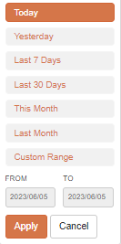
  + Click ‘Apply’ once your desired date range has been set
  + Ensure the checkbox has a ‘blue checkmark’ – the means the field has been ‘enabled’ and the system will search for data within the specified date range
  + 
* Repeat the steps used for ‘Creation Date’ if you wish to search by ‘Scheduled Date’
  + 
* Clients can also filter by ‘Service Type’ – Prepaid, Collect, 3rd Party
  + 
  + 
  + 
* Once any filters you have are set, click the ‘Filter’ icon to bring up results:
  + 
* Clients can ‘Clear’ all filters by clicking the ‘Clear’ icon:
  + 
* Clients can ‘Export’ data on the screen to a .CSV file by clicking the ‘Export’ icon
  + 

Jobs can also be tracked by following the below link and entering a Shipment Reference Number OR Barcode

* <https://www.mbwcourier.ca/>

Once on the main page of the MBW Courier website, enter shipment information in the ‘Track a Shipment’ field:

* 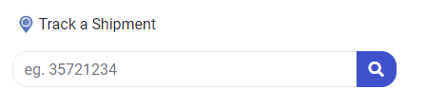
* Once Shipment Reference Number OR Barcode has been entered in this field, click the ‘magnifying glass’ icon 